Light Emitting Diodes
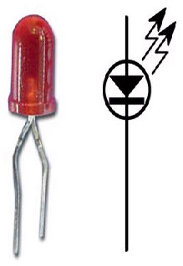
- Functions the same as a standard diode
- Anode- longer leg
- Cathode- shorter leg
- Illuminates when forward biased
- Schematic symbol for a LED shown above

